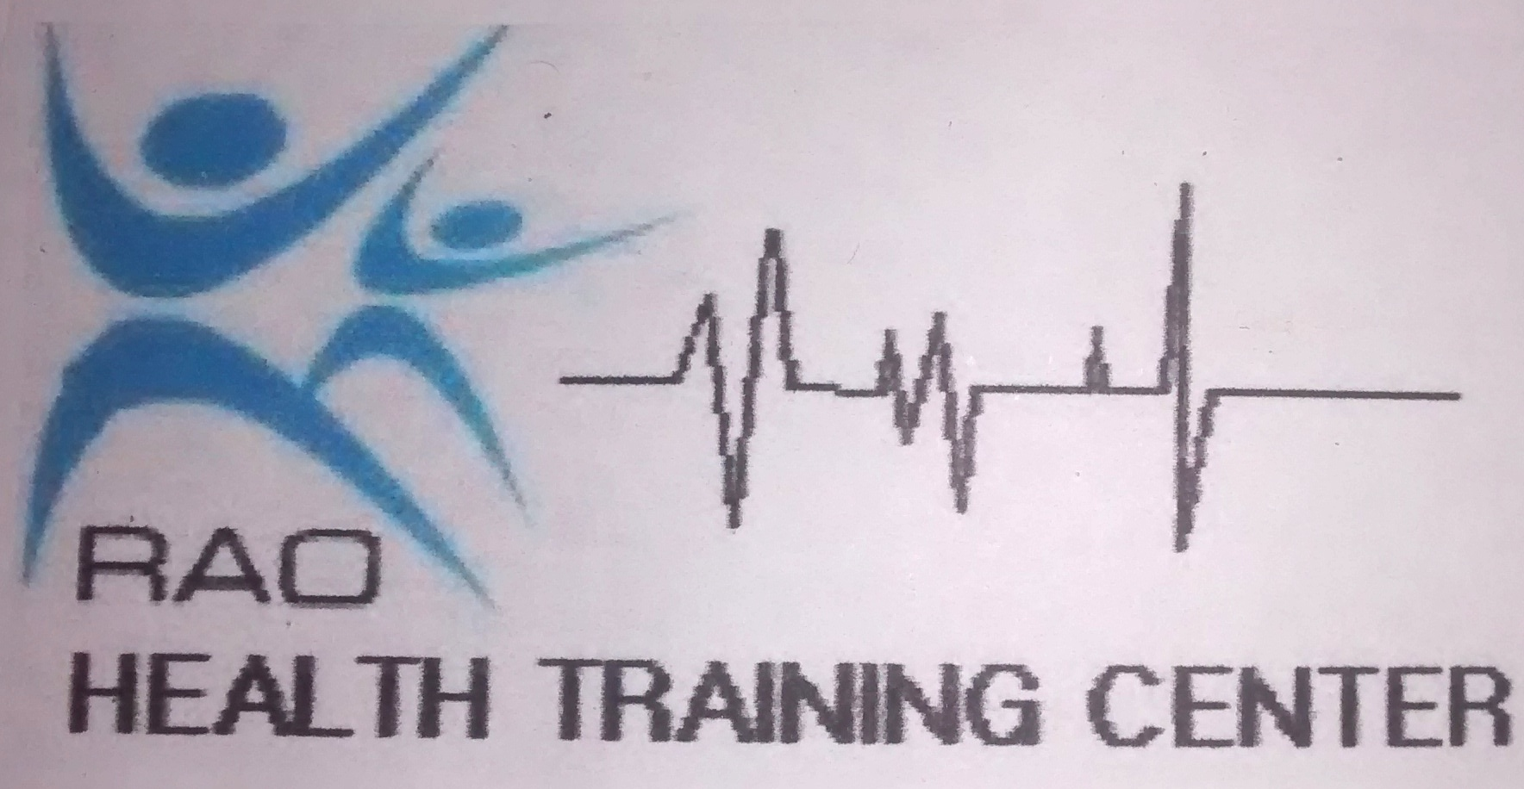
RAO HEALTH TRANING CENTRE
P.O.Box 42, SHIRATI – RORYA
MARA - TANZANIA

Dear MR/ Ms ___________________________________________ DATE: 21/1/2021

REF: JOINING INSTRUCTION FOR PROGRAM IN CLINICAL MEDICINE(FIRST YEAR)

I would like to congratulate you for your successful selection to join RAO Health Training Centre to pursue Certificate/Diploma in Clinical Medicine Course in Mara region.

The school will begin promptly 1/04/2021. You are required to report on 21/03/2021 for appropriate logistics. The candidate reporting later than TWO (2) WEEKS after the commencement of study will not be accepted and will automatically loose his/her vacancy.

- FEES STRUCTURE.
FIRST SEMESTER
EXPLANATION | TANZANIAN (TSH). | NON-TANZANIAN
School Registration Fee | 100,000.00 | 100,000.00
Tuition fee | 825,000.00 | 975,000.00
Health Insurance | 60,000.00 | 60,000.00
Procedure and Student Handbooks | 60,000.00 | 60,000.00
Practical Site fee | 150,000.00 | 150,000.00
T-Shirt | 15,000.00 | 15,000.00
Examination fee on 1st Semester | 120,000.00 | 120,000.00
Development fee | 150,000.00 | 100,000.00
Identity card fee | 10,000.00 | 10,000.00
Sub Total | 1,490,000.00 | 1,640,000.00
SECOND SEMESTER
Tuition Fee | 825,000.00 | 975,000.00
Examination fee on 2nd Semester | 120,000.00 | 120,000.00
Sub Total | 945,000.00 | 1,095,000.00
ANNUAL Total | 2,435,000.00 | 2,735,000.00

- This fee is payable in four installments.
First installment to be paid before 20th march 2021, Tsh 890,000.00 for Tanzanians, for Non Tanzanian 1,040,000.00 shs.
Second installment to be paid before 20th June 600,000 shs for both.
Third installment to be paid before 20th September 545,000.00 shs for Tanzanian, and for non Tanzanian 695,000.00 sh.
Fourth installment to be paid before 20th December 400,000.00shs for both

NB. No student will be enrolled before completing the first installment

- The money is paid at:

National Micro-Finance Bank (NMB):
Bank Account number: 32810003985
Account Name: RAO HOSPITAL HTC

- WE DO NOT ACCEPT CASH FOR TUITION PAYMENTS AT OUR INSTITUTION
- You are required to produce the pay-in-slip during the reporting day or you cannot be registered.
- ANY PAYMENTS MADE WILL NOT BE REFUNDED.

- OTHER CHARGES:

- ANNUAL FEES PAYED TO MINISTRY OF HEALTH
  - NATIONAL EXAMINATION FEE 150,000.00/=

Fees are to be paid at the bank listed below and original pay in slip must be delivered to college administration upon registration:

NBC Corporate Branch
Account name – Health Service Fund
Account no. 0111-030-12059

- Any student who does not pass the MOHSW final examination must pay the cost related to supplementary examination(s), which will be determined by the hosting facility and subjects to be supplemented.

- FIELD WORK 200,000/=

- SELECTED CANDIDATES ARE REQUESTED TO COME WITH THE FOLLWING:

You are required to come with the following personal belongings:
- 2 pairs of leather-black covered shoes, 2 pairs of black-socks (for male)
- 2 pairs of leather-white covered shoes, 2 pairs of white-socks (for female)
- A mattress (3 x 6)
- Bath towel, basin and a bucket
- White or Pink Sweater
- Original Certificates of Form IV or Form VI with copies
- 4 passport size pictures
- Counter books (4quires) 10 pieces, and 6 notebooks
- Pencils, rubber-eraser, sharpener and a ruler
- A pair of sportswear: Green T-shirt and blue shorts
- Uniform (see below the attached explanations for it)
- 2 rims of A4 plain paper

- BASIC LEARNING MEDICAL EQUIPMENTS
All students are required to come with the following equipments:
- Clinical thermometer
- Stethoscope
- Sphygmomanometer
- Tape measure
- 1 Box of Disposable Gloves

- Selected candidates must come with original certificate which shows pass grade of at least D in Physics/engineering sciences, chemistry, biology, math and English. Candidates with certificates other than that issued by NECTA should send it to NECTA for equivalency before joining studies.

- Non-Tanzanian citizens must complete immigration formalities before joining and must come with a permanent passport.

- CODE OF CONDUCT

RAO Health Training Centre believes in equal opportunity and does not discriminate against any student or prospective student on the basis of race, sex, origin disability or religion. Thus, you are supposed to abide with the school rules and regulations attached to this letter and sign below if you agree and accept the offer.

You are warmly welcome and I wish you God’s blessings through your academic work at the centre.

…………………………
PRINCIPAL - RAOHTC

……………….…… …………………………… …..……………
Applicant signature Parent/Guardian signature Date

KANUNI NA SHERIA ZA CHUO CHA RAO HTC

- Kwa miaka yote ya masomo mwanafunzi haruhusiwi kuwa na shughuli nyingine zissizohusiana na masomo yaliyokuleta hapa Chuoni.

- Ni lazima mwanafunzi afuate sheria, maadili na taratibu za jamii wakati wote wa masomo yake hapa Chuoni.

- Kazi zisizo za lazima kama kufua, kupiga pasi n.k zifanyike Jumapili au Jumamosi isipokuwa kazi ya kutunza usafi wa mazingira.

- Inawapasa wanafunzi wawe waaminifu daima; adhabu kali itatolewa kwa udanganyifu utakaofanyika wakati wowote..

- Wakati wowote mwanafunzi akiwepo katika Eneo la chuo na hospitali, ni lazima awe kwenye sare ya chuo.

- Mgeni yeyote wa mwanafunzi haruhusiwi kuingia bwenini/Hospital , akae sehemu maalum ya wageni. Baada ya saa 12:00 jioni mgeni aharuhusiwi kuwepo kwenye maeneo la Chuo/Hospital na siku za wageni ni Jumamosi na Jumapili tu kuanzia saa 07:00 mchana hadi saa 12:00 jioni. kwa wanafunzi wanokaa bwenini.

- Mwanafunzi atawajibika kufanya usafi{IPC} wa bweni lake, darasa, viwanja vya Chuo/Hospital na sehemu zingine atakazopangiwa na uongozi wa Chuo/Hospitali. Katika Cafeteria ya chuo.

- Radio na vyombo vya muziki haviruhusiwi chuoni.

- Kwa wanafunzi watakaa katika bweni la chuo. Kila Mwanafuzi atajitegemea kwa chakula chake. Pia Chuo kina huduma ya chakula kwa kujitegemea (breakfast, lunch and supper). Katika bwalo la chuo. Hairuhusiwi kupika bwenini.

- Kila mwanafunzi atapewa likizo ya siku ishirini na nane (28) au wiki nne (4) kwa mwaka na siku kumi na nne (14) au wiki mbili kabla ya kuanza mwaka mpya wa masomo. Siku ishirini (20) za ugonjwa ndani ya miaka mwili (2) zinakubalika. Siku kumi na nne (14) zaidi ya hapo hatafanya mtihani wa kuhitimu wa Serikali.

- Mwanafunzi akikosekana majuma matatu (3) mfululizo Chuoni atarudia mwaka.

- Mwanafunzi akiugua aende kwanza kwa Mwalimu wa Zamu/Warden ili apewe sick-sheet kabla ya kwenda kwa Mganga. Kisha rudisha sick-sheet ofisini (E.D.) chuoni.

- Hairuhusiwi kwa mwanafunzi wa kike au kiume kuwa na uhusiano wa kimapenzi/uchumba wakati wa masomo, ama sivyo wataachishwa masomo.

- Mwanafunzi yeyote wa kike atakayepata mimba akiwa masomoni ataachishwa masomo kwa mwaka mmoja, na mwanafunzi wa kiume akijulikana amempatia mwanafunzi mwenzie wa kike mimba pia naye ataachishwa kwa muda wa mwaka mmoja.

- Kila mwanafunzi lazima ashiriki kikamilifu katika shughuli za kujitegemea (self-reliance). Mwanafunzi atakayeonyesha ulegevu, utoro na uzembe katika shughuli hizo atachukuliwa hatua kali.

- Kila mwanafunzi analazimika kushiriki katika michezo (k.m. mpira) na shughuli za starehe (k.m kwaya, sanaa) kwani ni sehemu ya masomo.

- Mwanafunzi haruhusiwi kwenda na simu darasani au hospitalini.

- Makosa yanayoweza kumwondoa mwanafunzi Chuoni ni kama yafuatayo:

- Uasherati, Ulevi, Utoaji mimba, uvutaji sigara, kutumia bangi au dawa za kulevya

- Matusi, ugomvi na kupigana

- Kutowatii Walimu na Wakuu wa Hospitali

- Wizi wa aina yoyote

- Udanganyifu na uongo wa aina yoyote

- Kutohudhuria darasani bila sababu maalum

- Kuvunja taratibu za chuo, kanuni na sheria za nchi

- Baada ya kusoma kanuni na sheria za Chuo, hakikisha umeweka saini katika sehemu yako hapa chini na mzazi/mlezi wako.

- Mwanafunzi ni lazima awepo bwenini saa 2:00 Jioni Kila siku.

NAKUBALIANA NA KANUNI/SHERIA ZILIZO KWENYE BARUA YA KUJIUNGA NA CHUO HIKI NA NINA AHIDI KUYATEKELEZA VEMA.
Jina kamili la Mwanafunzi _______________________________________________
Saini ya mwanafunzi ____________________________________________________
Jina la Mzazi/Mlezi _____________________________________________________
Saini ya Mzazi/Mlezi ____________________________________________________
Anuani ya Mzazi/Mlezi: __________________________________________________
___________________________________________________
___________________________________________________
Simu: ______________________________________________
Email: _____________________________________________

KARIBU SANA KATIKA CHUO CHA RAO HEALTH TRAINING CENTRE (RAOHTC) ILI UPATE ELIMU BORA NA SI BORA ELIMU

---------tera here-------chana hapa-------tear here-------chana hapa-------tear here-------------

THE OFFER ACCEPTANCE:
Read carefully the above letter and the college rules, then if you accept the offer tear up this piece and return it to RAO Health training Centre, P.O. Box 42, Shirati – Rorya
Student’s Name: ________________________________________Signature__________

Parent’s/Guardian Name _________________________________Signature __________
Date _________________
NB: We only accept hard copy. Please also confirm your acceptance through mobile number listed at the top of the page or through email.
SARE YA WANAFUNZI

Wizara ya Afrya na Ustawi wa Jamii inasimamia mwenendo wa taaluma na nidhamu za wanafunzi wanapokuwa masomoni katika vyuo vya Afya. Kwa kufanya hivi Wizara inawandaa vijana hawa kuwa watumishi bora wa Afya kwa tabia na umahiri katika kazi.
Wizara imeagiza kwamba wanafunzi wote walioko masomoni katika vyuo vya Afya wanatakiwa kuvaa sare zifuatazo:
MWANAMKE:
Magauni mawili (2) ya tetron nzito nyeupe, yenye mikono mifupi. Hakikisha magauni yanavuka magoti (inch 2 chini ya goti, isiwe na mpasuo nyuma. Mshono wake ni uwe sawa na sare za wauguzi na iwekwe utepe wa khaki mabegani. Viatu vyeusi vyenye visigino vifupi.
Makoti mawili (2) meupe na masafi. Koti moja liwe refu na mikono mirefu na linguine fupi na mikono mifupi. ‘Jeans’ siyo vazi la kuvaa darasani au wakati wa mazoezi kwa vitendo hospitalini.
MWANAUME:
Suruali mbili (2) za rangi ya khaki tetron. Mwanafunzi hatakiwa kushona suruali inayobana. Mashati mawili meupe yenye mikono mifupi. Viatu vya ngozi vyeusi.
Makoti mawili (2) meupe na masafi. Koti moja liwe refu na mikono mirefu na linguine fupi na mikono mifupi. ‘Jeans’ siyo vazi la kuvaa darasani au wakati wa mazoezi kwa vitendo hospitalini.

Unasisitizwa kuzingatia maelekezo yaliyotolewa ili kujenga nidhamu.

SCHOOL OF CLINICAL MEDICINE/CERTIFICATE/DIPLOMA

